Transform Your Event with JK Events Decor: Leading Event Decorators

When it comes to hosting an unforgettable event, the right decor can make all the difference. Whether you're planning a wedding, corporate event, birthday party, or any special occasion, JK Events Decor stands out as the premier choice for top-notch event decoration services. Our team of expert event decorators is dedicated to transforming your vision into a stunning reality.

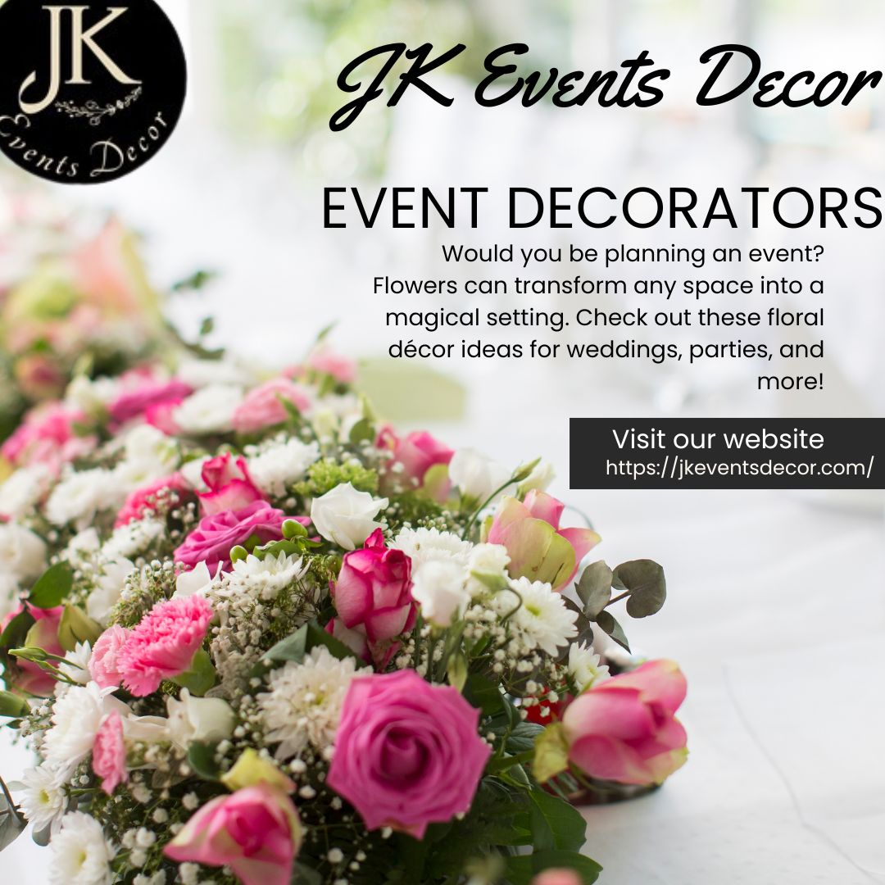

# Why Choose JK Events Decor for Your Event?

At JK Events Decor, we understand that every event is unique and deserves a personalized touch. Our commitment to excellence and attention to detail ensures that we deliver exceptional results for every event we decorate. Here’s why JK Events Decor should be your go-to choice for [Event Decoration:](https://justpaste.it/redirect/d1b4v/https%3A%2F%2Fjkeventsdecor.com%2F)

1. **Customized Event Decor**: We believe in creating decor that reflects your personality and style. Our event decorators work closely with you to understand your vision and bring it to life with custom designs tailored to your event's theme and ambiance.
2. **Expert Team of Decorators**: Our team comprises experienced and creative professionals who are passionate about event decoration. With their expertise, you can rest assured that your event will be adorned with elegance and sophistication.
3. **Wide Range of Services**: From weddings and corporate events to birthday parties and social gatherings, we offer a comprehensive range of decoration services. No matter the size or type of event, JK Events Decor has got you covered.
4. **High-Quality Materials**: We use only the finest materials and decor items to ensure that your event looks spectacular. Our attention to quality ensures that every detail is perfect, from floral arrangements to lighting and furniture.
5. **Affordable Pricing**: Exceptional event decor doesn’t have to break the bank. JK Events Decor offers competitive pricing without compromising on quality, making luxury event decoration accessible to all.

# Our Event Decoration Services

JK Events Decor provides a wide array of services to cater to various event types and themes. Here are some of the key services we offer:

* **Wedding Decor**: Your wedding day is one of the most important days of your life, and we are here to make it magical. From elegant floral arrangements and stunning centerpieces to beautiful lighting and drapery, our wedding decor services will create a romantic and unforgettable atmosphere.
* **Birthday Parties**: Make birthday celebrations extra special with creative and vibrant decorations. Whether it’s a milestone birthday or a themed party, we ensure that the decor is fun, festive, and memorable etc
* **Reception Decor:**A reception is a significant part of any wedding or event, and the decor plays a crucial role in setting the tone. At JK Events Decor, we specialize in creating breathtaking reception decor that leaves a lasting impression on your guests.
* **Jaggo/Sangeet Decor:** The Jaggo and Sangeet ceremonies are vibrant and joyous pre-wedding celebrations that deserve equally lively and colorful decor. JK Events Decor excels in creating festive and enchanting decor for these special occasions.

# The JK Events Decor Process

At JK Events Decor, we follow a structured process to ensure that your event decor is executed flawlessly:

1. **Consultation**: We begin with a detailed consultation to understand your vision, preferences, and budget. This helps us create a customized decor plan tailored to your needs.
2. **Design and Planning**: Our team develops a design concept based on your requirements. We present you with ideas and themes, incorporating your feedback to finalize the decor plan.
3. **Execution**: On the day of the event, our team arrives early to set up the decor, ensuring that every detail is perfect. We work efficiently and meticulously to bring the design to life.
4. **On-Site Coordination**: Throughout the event, we provide on-site coordination to manage the decor and address any last-minute adjustments, ensuring a seamless experience.
5. **Takedown and Cleanup**: After the event, we handle the takedown and cleanup of all decor items, leaving the venue in pristine condition

# Contact Us

Ready to transform your event with stunning decor? Contact JK Events Decor today to discuss your event decoration needs. Our team is here to help you create an unforgettable experience with our expert event decoration services.

Visit our website or call us at [phone number] to book a consultation. Let [JK Events Decor](https://justpaste.it/redirect/d1b4v/https%3A%2F%2Fjkeventsdecor.com%2F) bring your vision to life and make your event truly spectacular.

For more information, check out our social media pages and see our latest projects and client testimonials. With JK Events Decor, your event is in the best hands.

JK Events Decor

Surrey, BC, Canada.

(604) 353-5959

info@jkeventsdecor.com

[https://jkeventsdecor.com/](https://justpaste.it/redirect/d1b4v/https%3A%2F%2Fdrsunilmjain.com%2F)

[https://maps.app.goo.gl/zzm34JopEojaaTka8](https://justpaste.it/redirect/d1b4v/https%3A%2F%2Fmaps.app.goo.gl%2Fzzm34JopEojaaTka8)